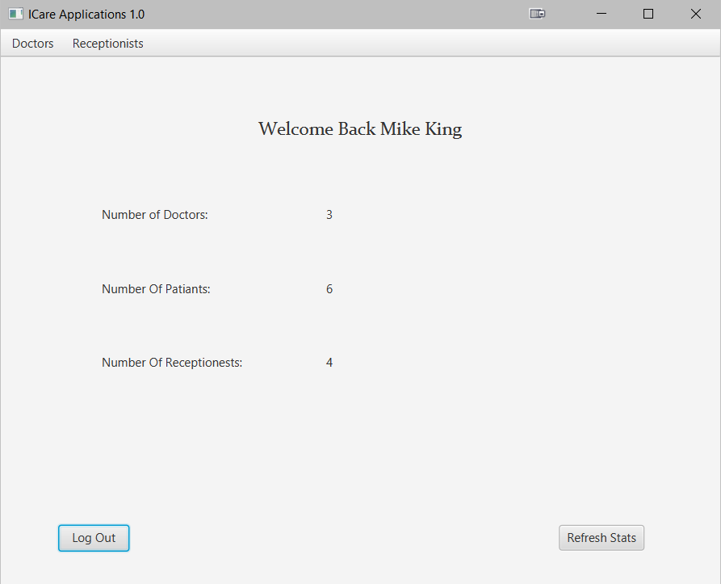

Req001

Show welcome in the name of the manager

Req0003:

On the first line Show number of doctors in the system

Req004:

On the second Show number of patients in the system

Req005:

On the Third line show number of Receptionist in the system

Req006:

Pressing "log out" button at any time should close the page and log the time the user logged out and open the log in page

Req007:

Pressing "Refresh stats" to connection with database

Req008:

Menu tab will be displayed at the top bar to navigate to edit doctor screen

Req009:

Menu tab will be displayed at the top bar to navigate to edit Receptionist screen

Login – Graphical User Interface

Req009:

Req0009a - Label "number of doctor" visible: True.

Req0009b - label " number of doctor in system " visible :true

Req0009c - Label " number of patients " visible: True.

Req0009d - Label " number of patients in system " visible: True.

Req0009e - Label " number of Receptionist " visible: True.

Req0009f -Lebel " number of Receptionist in system" " visible: True.

Req0009g - Button "log out" enabled: True.

Req0009h - Button "Refresh stats" enabled: True.

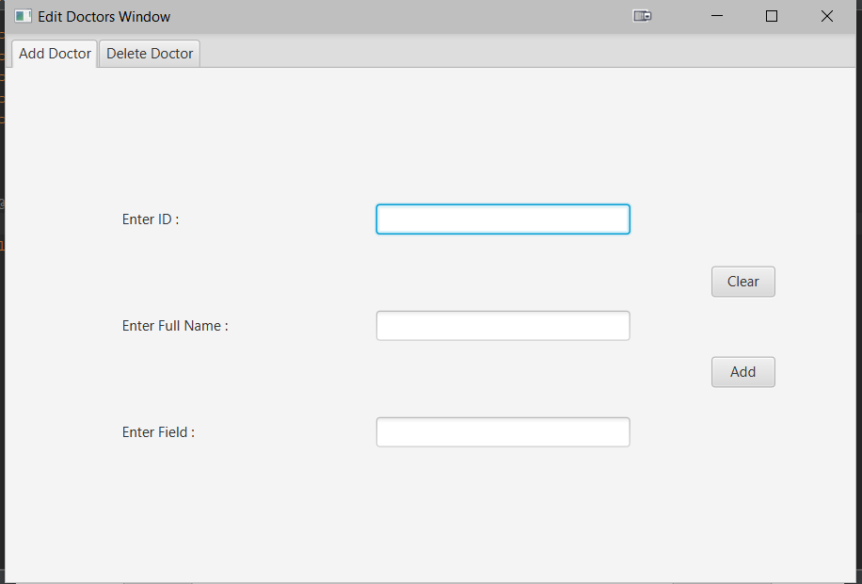

Req0010:

In the first line enter id doctor

Req0011:

Enter full name of doctor

Req0012:

Enter field

Req0013:

Pressing "clear " to clear the data

Req0014:

Pressing "add" to add the doctors

Req0015:

Menu tab will be displayed at the top bar to navigate to add doctor screen

Req0016:

Menu tab will be displayed at the top bar to navigate to Delete doctor screen

Doctor – Graphical Interface

Req0017:

Req0017a - Label "Enter ID" visible: True.

Req0017b - Textbox " Enter ID "", enabled :True, visible :true

Req0017c - Label " Enter Full Name " visible: True.

Req0017d - Textbox " Enter Full Name " ", enabled :True , visible: True.

Req0017e - Label " Enter field " visible: True.

Req0017f Textbox" Enter field " ", enabled :True, visible: True.

Req0017g - Button "clear" enabled: True.

Req0017h - Button "Add" enabled: True.

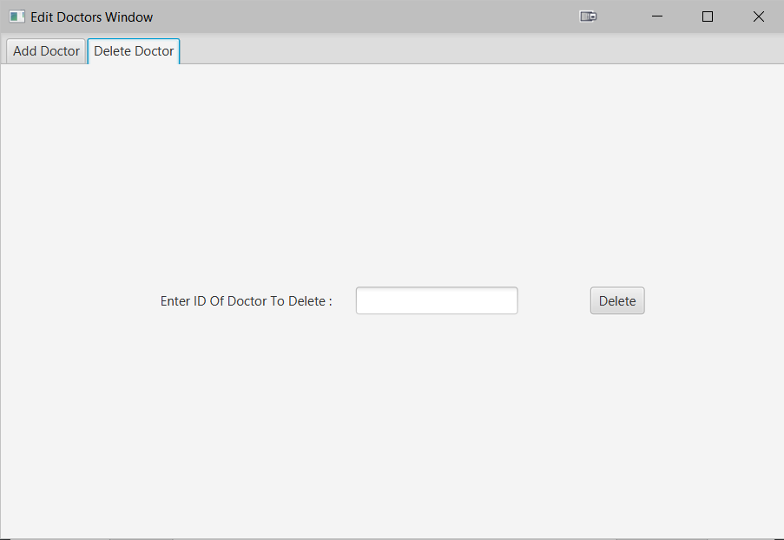

Req0018:

Enter Id of doctor to delete the Appointment Booking

Req0019:

Pressing "Delete " to delete the doctor

Delete Doctor – Graphical Interface

Req0020:

Req0020a - Label " Enter Id of doctor to delete " visible: True.

Req0020b - Textbox " Enter Id of doctor to delete "", enabled :True, visible :true

Req0020c - Button "Delete" enabled: True.

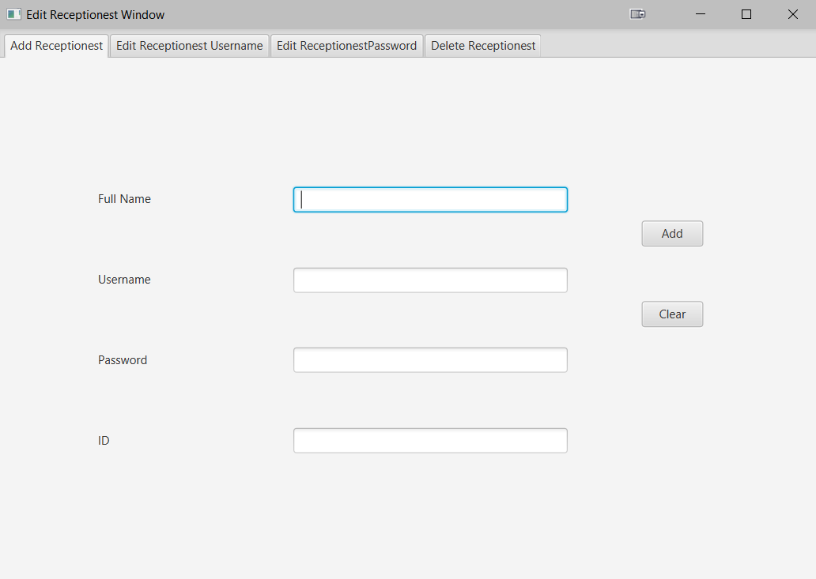

Req0021:

In the first line enter full name of Receptionest

Req0022:

Enter the username

Req0023:

Enter Password

Req0024:

Enter ID to add Receptionest

Req0025:

Pressing "Add " to Add the Receptionest

Req0026:

Pressing "Clear " to Clear the Data

Req0027:

Menu tab will be displayed at the top bar to navigate to Add Receptionist screen

Req0028:

Menu tab will be displayed at the top bar to navigate to Edit Receptionist username screen

Req0029:

Menu tab will be displayed at the top bar to navigate to Edit Receptionist paasword screen

Req0030:

Menu tab will be displayed at the top bar to navigate to Delete Receptionist screen

Receptionist – Graphical Interface

Req0027:

Req0027a - Label "Full name" visible: True.

Req0027b - Textbox " Full name "", enabled :True, visible :true

Req0027c - Label " Username " visible: True.

Req0027d - Textbox " Username " ", enabled :True , visible: True.

Req0027e - Label " Password" visible: True.

Req0027f Textbox" Password " ", enabled :True, visible: True.

Req0027g - Button "clear" enabled: True.

Req0027h - Button "Add" enabled: True.

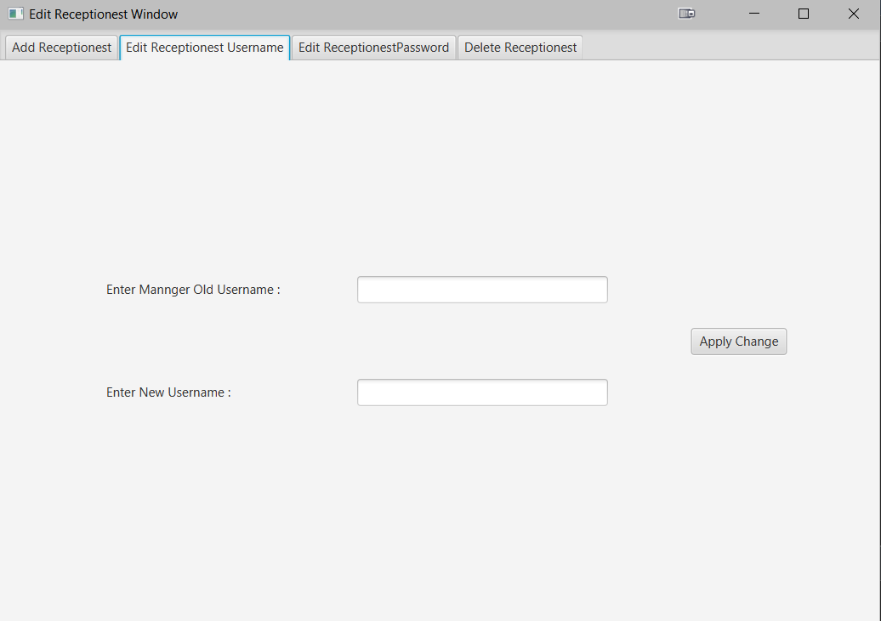

Req0028:

In the first Enter manger old username

Req0029:

In the second line Enter New Username

Req0030:

Pressing "Apply change" to save changes to database

Receptionist – Graphical Interface

Req00031:

Req00032a - Label " Enter manger old username " visible: True.

Req0033b - Textbox " Enter manger old username "", enabled :True, visible :true

Req0034c - Label " Enter New username " visible: True.

Req0035d - Textbox " Enter New username " ", enabled :True , visible: True.

Req0036e - Button "Apply change" enabled: True.

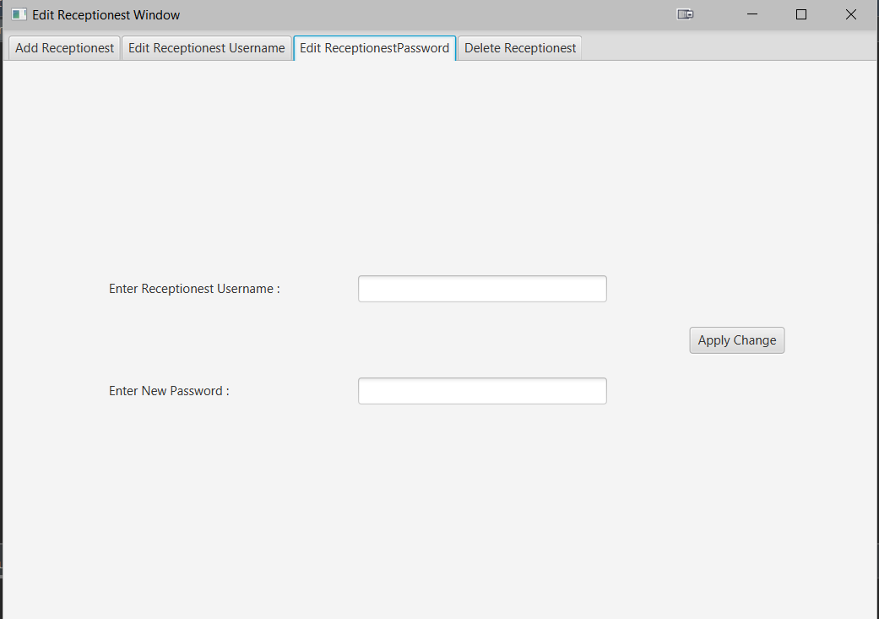

Req0037:

In the first Enter Receptionist username

Req0038:

In the second line Enter New Password

Req0039:

Pressing "Apply change" to save changes to database

Receptionist – Graphical Interface

Req0040:

Req0040a - Label " Enter Receptionist username " visible: True.

Req0040b - Textbox " Enter Receptionist username "", enabled :True, visible :true

Req0040c - Label " Enter New Password " visible: True.

Req0040d - Textbox " Enter New Password " ", enabled :True , visible: True.

Req0040e - Button "Apply change" enabled: True

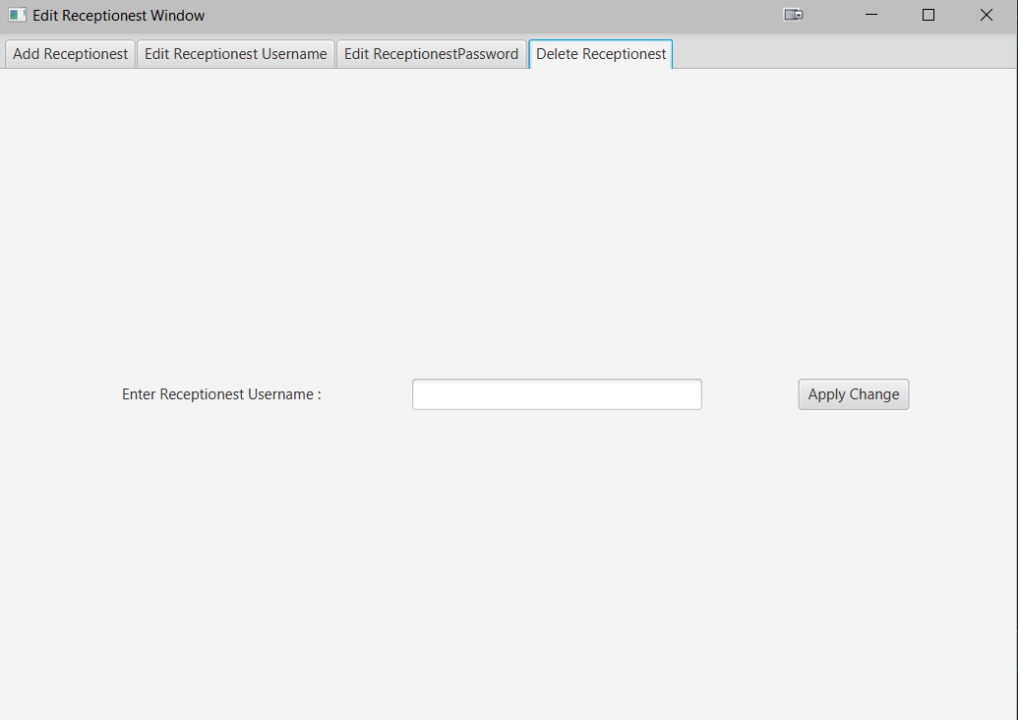

Req0041:

Enter Receptionist Username

Req0042:

Pressing "Apply change" to save changes to database

Receptionist – Graphical Interface

Req0043:

Req0044a - Label " Receptionist Username " visible: True.

Req0045b - Textbox " Receptionist Username "", enabled :True, visible :true

Req0046e - Button "Apply change" enabled: True.

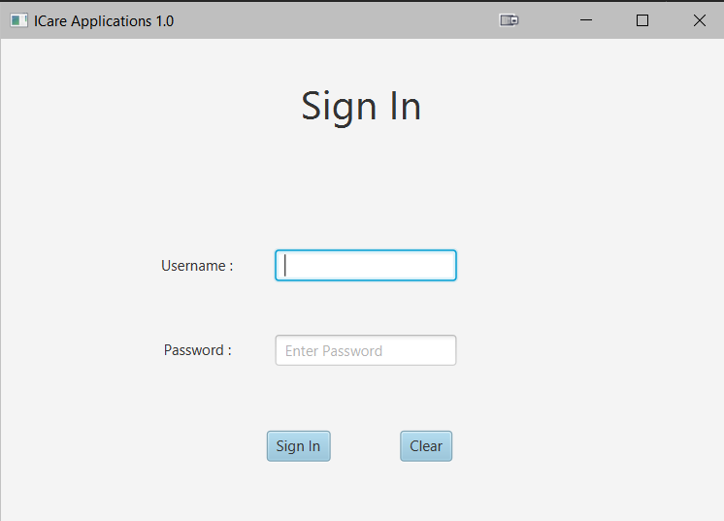

Req0047:

Show Sign in

Req0048:

On the first line Enter username

Req0049:

On the second line Enter Password

Req0050:

Pressing "sign in" to join in the application

Login – Graphical Interface

Req0002:

Req0002a - Label " Username" visible: True.

Req0002b - Textbox " Username "", enabled :True, visible :true

Req0002a - Label " password" visible: True.

Req0002b - Textbox " password "", enabled :True, visible :true

Req0002c - Button "Sing in" enabled: True

Req0002d - Button "clear" enabled: True.